Work set for Year 9 – week beginning Monday 15th June
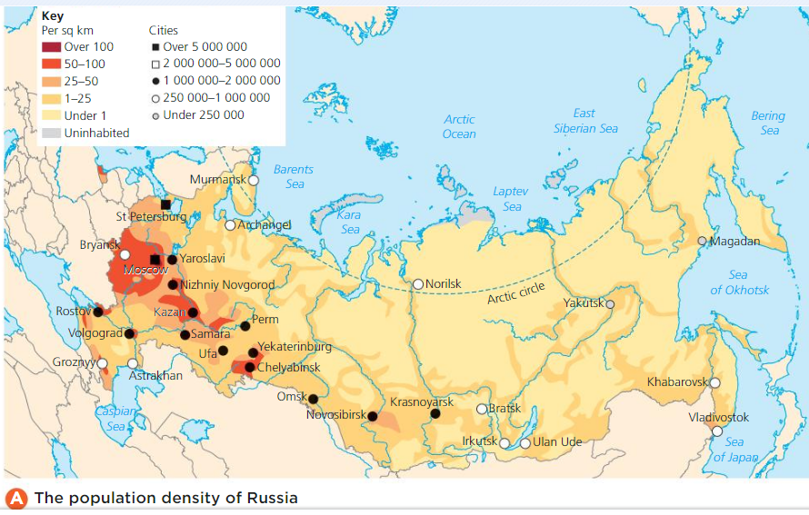
This week’s task is based on what you have learnt about the physical geography of Russia – landscape and climate – in the past few weeks. You may have to do a bit of further research. Answer the questions in full sentences.
- What does population density mean?
- How is population density calculated?
- What is the total population of Russia?
- What is the population density of Russia?
- Why do you think population density is more useful than the figure for the total population?
- What do sparsely and densely populated mean?
- Which categories on the map show the densely populated areas?
- Which categories on the map show the sparsely populated areas?
- Write a short paragraph to describe the distribution of population in Russia. This means how are people spread out? eg The most densely populated areas are found in the .......... The most sparsely populated areas are found in the .......
10. Where are the major cities located in Russia?
11. Explain why, despite being the largest country in the world by area, so much of Russia is sparsely populated.
12. Why are the densely populated regions where they are?

