CONTENTS

Welcome to All Hallows …………………………………………………………..
Letters to Parents ………………………………………………………………….
Arrangements for Pupils …………………………………………………............
Arrangements for Parents ……………………………………………….............
For Pupils on Arrival at All Hallows ………………………………………………
Equipment – Check List ………………………………………………................
Involving Pupils in School Life ……………………………………………………
Chaplaincy ………………………………………………………………………….
School Counsellor …………………………………………………………………
Basic Routine Procedures for Pupils ……………………………………………
Music School ……………….…………………………………………..................
School Uniform ……………………………………………………………............
Plan of the School …………………………………………………………………
Holiday List …………………………………………………………………………
Behaviour for Learning…………………………………………………...............
The Classroom Code of Conduct ……………………………………………......
Pupil Acceptable Use Agreement …………………………………………….....
Parent Acceptable Use Agreement ……………………………………………...
Cashless Dining System ………………………………………………………….
Privacy Notice – Data Protection Act 1988 ……………………………………..
ParentMail Registration …………………………………………………………...

Welcome to All Hallows

Please read this booklet carefully and note all the relevant
information. It is hoped that the information will help in
easing the move from Primary School to All Hallows.

Parents are asked to bring the booklet to the “New Intake
Evening” meeting on Thursday 25th June 2020,
as sections in it will be referred to. Parents may wish to
ask questions about the contents.



All Hallows Catholic High School opens on

THURSDAY 3rd SEPTEMBER 2020

Welcome to Year 7!!

We look forward to seeing you

To Parents of the New Intake 2020

Dear Parents

The following information is intended to help you and your child during the transition period from Primary School to All Hallows. The most important things to remember are that you are all welcome and that we are no further away than the end of a telephone line from being able to help you, if and when required.

The transition from Primary School to a rather large Comprehensive School can be a worrying experience for both parents and pupils. I would like to take this opportunity to reassure you that each year the vast majority of pupils experience few problems on arrival at their new school and within a few weeks all pupils have adjusted to the transition. Moving to a larger school with many more pupils and unfamiliar staff may seem overwhelming but in reality the new pupils will find their form tutors and classroom teachers most helpful and supportive. Above all, the Year 7 team are always at hand to solve problems and offer advice.

Many problems may seem of a trivial nature but to a pupil they can loom large. The following information is intended to overcome many of the seemingly trivial problems. Please read the booklet and the School Prospectus carefully. We will support as best we can but we also need your support, not just during the first few weeks of your child’s stay at All Hallows but all the way through his/her school career. We set high standards for the good of your child, please help us to maintain these standards.

Together we can look forward to your child having a happy and fruitful five years at All Hallows. You will have a further opportunity to meet me and my Senior Leadership Team at the Intake Evening, which will be held at All Hallows on Thursday 25th June 2020 at 7.00 p.m.

Mr C Horrocks
Headteacher

To Parents of the New Intake 2020

Dear Parents

May I extend a very warm welcome to you and your son/daughter. We are very pleased that you have chosen our school to continue the very important process of educating your child by building upon the excellent experiences gained in the primary school.

I hope that we will be able to work together to enable your child to achieve his/her full potential academically and to develop spiritually, morally and socially within a safe and secure environment.

Both you and your child will want reassurance about what lies ahead. Areas of concern for both pupils and parents can be overcome by seeking guidance from myself, my Assistant Head of Year or the Form Tutors. I will be pleased to talk to you at any time on the telephone or in person should you have any concerns, or simply if you wish to tell us about yourself or your child.

We want your child to be happy and content at All Hallows. Being realistic about your child’s academic ability and not over-pressurising him/her at first will ensure a good start. Pupils will be given ample opportunity to show their level of ability.

Please encourage your child to join in as many extra-curricular activities as possible. Being involved in the life of the school is very important, and pupils gain a great deal from their involvement.

My aim is to make sure that your child has a good start at All Hallows. I look forward to us working together to ensure that the first year is a happy and memorable one.

Mrs A Hall
Learning Manager – Year 7

Arrangements for Pupils prior to
attending All Hallows

1. There are regular meetings between the Headteachers of the four main contributory Primary Schools – St Oswald’s, St Teresa’s. St Mary Magdalen’s, Our Lady and St Gerard’s – and the Headteacher, Head of Year 7 and the Transition Manager at All Hallows to discuss the transfer of pupils.

2. Contact is made with the Headteachers of other contributory Primary Schools to discuss the transfer of pupils.

3. Pupils are seen in their Primary Schools by the Head of Year 7 and
the Transition Manager.

4. There is good and growing liaison between the Primary Schools and the High School in subject areas, notably Mathematics, English, Science, Music, Sport, Geography, History, French, Religious Education, Art, Technology and ICT.

5. A Transition Day takes place at All Hallows during the Summer Term for all new pupils to help them develop their sense of community within their new school.

6. Year 5 and 6 pupils sample a variety of lessons at All Hallows during the school year.

7. Year 6 pupils are invited to any productions/exhibitions etc., which take place during the year.

8. Website and Video-conferencing links have been developed.

Arrangements for Parents prior to their child attending All Hallows

- In September, the Headteacher and the Deputy Headteacher visit the four partner primary schools and meet parents of pupils in Years 5 and 6.
- Parents are invited to the school’s Open Evening held during October. Samples of work and demonstrations of lessons are on view.
- The Headteacher and Head of Year 7 visit the four main contributory Primary Schools to talk to parents in the evening about All Hallows. Parents of children in non-contributory Primary Schools are invited to All Hallows for a similar presentation.

- Parents are invited to a meeting at All Hallows in July where they can meet the Headteacher, the Deputy Head, the Head of Year 7, the Year 7 Form Tutors and PTFA representatives.

- A School Prospectus has been given to parents, which should be read carefully.

- It is possible to show parents around the school by prior arrangement at any time of the year.

- Parents are invited to phone in at any time. The Learning Manager, Mrs Hall, will return your call as soon as possible.

for pupils on arrival at all hallows

- Pupils arrive on the first morning, are welcomed and directed to the Arts Theatre for their assembly.

- Pupils are placed in their Tutor Groups and shown to their Form Rooms.
- Lockers are allocated.



- Pupil organisers are distributed.

- Academic and Homework timetables are given out.

- Lunch organisation is explained.

- Daily procedures are explained.
- Movement to and boarding of Special Buses is discussed.

- The system of rewards and sanctions is explained.
- Pupils are encouraged to ask questions throughout the day.
- A Plan of the school is provided in this booklet for pupils.
- They spend lessons 1 and 2 in form and then follow their regular timetable.



ALWAYS ASK IF YOU DO NOT UNDERSTAND!

equipment – checklist

 |  | Your Check
1 | Colour pencils – Geography and Technology lessons require them.
2 | Two aprons (white/cream) – Cream for Art and Technology and a white one for Food Technology. Available from uniform supplier.
3 | A dictionary – NOT a large, expensive one. To be kept at home.
4 | PE kit and towel required when on rugby.
5 | Padlocks are to be purchased for £2.50 from school to ensure that it will fit the locker. Please see the enclosed letter for further details.
6 | Key ring for locker key.
7 | All items of clothing and equipment must be clearly labelled with the pupil’s name.
8 | Stationery: A selection of pens, preferably rollerball, in blue or black ink. HB pencils, pencil eraser, pencil sharpener; large Pritt stick and a 12” ruler all in a pencil case marked with the pupil’s name. Felt tips / fineliners are optional. Correction fluid (e.g. Tipp-ex) is not allowed.
9 | Purple and green pens for peer assessment and corrections.
10 | A suitable bag to carry books
11 | The wearing of an expensive coat is to be discouraged
12 | Large amounts of money should not be brought into school
13 | Bicycles must have a secure lock
14 | Mobile phones, Smart watches ad iPods etc. are best left at home in line with school policy.
15 | Maths kits will be sold by the Maths Department. Please see the enclosed letter for further details.
16 | A cheap pair of headphones (in ear) for Languages.
17 | Shading pencils – 2B, 4B, 6B and colour pencils for Art.

INVOLVING PUPILS IN SCHOOL LIFE

During Year 7 we try to integrate pupils into school life – taking part in extra activities such as sport and music help a young person to feel part of the new community.
Here are some of the activities the pupils are involved in:

Sport

Football Cross Country Running Table Tennis
Netball Handball Hockey
Badminton Rugby League Gymnastics

The Year 7 sports teams are always competitive and many pupils train and attend trials regularly.

Music

Learning to play an instrument.
Joining the Jazz Band, Concert Band, Choir, Guitar Group, Rock Bands, Session Band, Music Ministry Team and taking part in the Year 7 Talent Show and Secondary Schools Music Festival.

Social and Educational Visits

In recent years lots of trips have taken place:

The school has visited many parts of Europe, including France, Germany and Spain and there has been a Geography trip to West Coast USA, Modern Languages and Technology trip to China and a Performing Arts Trip to New York / Florida.
All Year 7 pupils go on a retreat during school time for one day in the Autumn Term.

Details of all trips to Europe and beyond for the next two school years will be listed on the School Website from July 2019.

Charity Collection

During 2017/2018 to date, the school raised over £2,000 for the St Catherine’s Hospice, as well as over £2,000 for CAFOD.
Year 7 will also have their own year charity from September 2019.

Performing Arts

Over 140 pupils were involved in the 2018 school production, ‘Grease’. Many Year 7 pupils took part in this show and in several other Performing Arts activities throughout the year. For further details, please see our Head of Performing Arts, Mrs Colclough.



CHAPLAINCY

What is the Chaplaincy?

We aim to serve all members of our school community by offering them encouragement, support and friendship on their faith/life journey; helping to create and nurture the Christian ethos of the school through fostering prayer, liturgy and Christian example.

Our full time lay chaplain is Kate, whose job is to walk alongside all pupils and staff, and to challenge us to really live out our Mission Statement “Growing together in the Spirit of Christ’s Love”. There are many others who play their part in the role of chaplaincy in the school and pupils are encouraged to be actively involved.


Chaplaincy Activities

- Faith in Action Team – the opportunity to work towards a Gold / Silver / Bronze Award for Christian Service in the Community.
- Various Masses, Liturgies and Services of Word and Communion throughout the year.
- Opportunity for quiet reflection and prayer during the school day.
- Retreats and away days.
- Opportunities for the Sacrament of Reconciliation.
- Links with feeder school parishes, families and the wider community.

- Awareness of ‘wider church’ through various outside agencies e.g. CAFOD and Amnesty International.
- Collective Worship.
- Chaplaincy Choir.

SCHOOL COUNSELLOR

Our School Counsellor is Helen Molyneux she has been qualified as a Person Centred Counsellor since 2002 and has worked at All Hallows for 22 years. She is trained to provide opportunity for young people to talk about things that are concerning them in confidence, without judging them, and to help them work through these problems and the feelings that surround them.

What is spoken about depends on the individual but may concern stress, relationships, change, loss and distressing or traumatic events. Her work with young people involves support which can benefit emotional well-being, behaviour and performance in school, at home and in relationships. Sessions are weekly and are held in a private room and usually last for one period. Appointment times are varied so that time is not lost from any one subject. The meetings may be for a few sessions or longer term depending on the needs of the young person. This is reviewed regularly.

Should your son/daughter ever need to access this service your support would be greatly appreciated in showing them that this pastoral support is a normal and useful activity. Helen would be happy to discuss any concerns or questions you have about it.

There are various ways your son/daughter can access the service in school: pupils can refer themselves or can ask a teacher or Head of Year to refer them. There is also a posting box outside her room where they can post a note to me.

This is a confidential service which means it is a safe place for pupils to talk. The only time she is obliged to pass information on is if they or anyone else is at risk. This will always be done in line with the School Child Protection Policy.



basic routine procedures for PUpils

THE SCHOOL DAY

8.30 a.m. | Staff Briefing
8.40 a.m. | Staff and Pupils move to forms
8.45 a.m. | Registration or Assembly
9.00 a.m. | Lesson 1
9.50 a.m. | Lesson 2
10.40 a.m. – 10.55 a.m. | BREAK
10.55 a.m. | Lesson 3
11.45 a.m. | Lesson 4
12.35 p.m. – 1.20 p.m. | LUNCH
1.20 p.m. | Registration and Lesson 5
2.15 p.m. | Lesson 6
3.05 p.m. | DISMISSAL

Buses

Pupils travelling on school buses must:
- sit down;
- remain seated for the whole journey;
- get onto the bus only when told by a member of staff;
- pay or show their bus pass;
- pupils report any incidents to bus prefects;
- bus prefects report any issues to Mrs Washington.

Bicycles
Pupils should:
- ensure their bicycle is roadworthy;
- always wear a cycle helmet
iii) dismount at the school gate;
iv) wheel their cycle to the Cycle Shed
v) lock the cycle securely.

Lost Property
- Pupils are responsible for their own property and it should be marked or labelled with the pupil’s name. Expensive items of outdoor clothing, particularly fashion items, should not be worn to school.
- If money or valuables have to be brought to school, they should be left with the Head of Year for safe keeping;
- All items found should be handed in to the General Office or given to the relevant Head of Year.
- Pupils losing items should enquire at the General Office during breaks and approach their Head of Year who will advise them on the correct course of action;
- Each pupil is allocated a locker in which books, jackets etc. can be left.

Items not allowed in school
The following items are forbidden on school premises in order to maintain a clean and safe environment:
- Smoking materials, gum, e-cigarettes and associated item;
- Knives, aerosols, solvents, spirit based pens, fireworks, alcohol, drugs, liquid paper;
- Jewellery (except watches which may be worn by boys and girls and earrings – 1 pair of silver/gold studs for girls only);
- Magazines/media, which would not enhance the moral values upheld by the school.
- Mobile Phones – we discourage pupils bringing mobile phones to school. If one is brought it must be given to the Head of Year for safekeeping. Under no circumstances should mobile phones be used in school. Please see the school policy on this.

Absence Notes
- When a pupil is absent from school, parents/guardians are asked to inform the school by telephone between 8.00 a.m. – 8.45 a.m. or as soon after as possible;
- On returning after absence pupils must bring a letter from home explaining the absence;
- Failure to bring a letter can result in an unauthorised absence being recorded against the pupil;
- Only in “exceptional” circumstances can the Headteacher authorise absences for family holidays. A form must be completed prior to the holiday being taken and submitted to the Headteacher. These are available from the General Office and on the school website.
- In line with LCC policy, the school has the power to fine pupils when their attendance falls below a certain threshold.

Medicines
Please see the full Medicine Policy on the School’s Website for further details.

music school

In addition to class music, a wide range of extra curricular activities is available. Regular groups include the Concert Band, Choir, Jazz Orchestra, Rock Bank, Woodwind Ensemble and Guitar Club. The Department provides Music for school occasions such as Open Evening, whole school assemblies, in addition to Christmas and Summer Concerts and a host of other events. Members of the music society get the opportunity to visit the theatre and receive certificates and colours for their participation in the musical life of the school. Your son/daughter may also want to learn to play a musical instrument or have singing lessons.

The All Hallows Music School is jointly funded with contributions from the school and the parents:
- parental contribution ranging from £70 to £100 for a term’s lessons
- we provide high quality tuition appropriate to the needs and abilities of the pupils
- tuition is generally in small groups
- currently there are over 200 pupils receiving tuition

If you would like your son/daughter to receive tuition in September it is essential you book as soon as possible. Booking forms are to be returned by Thursday
25th June 2020.

Musical Instruments
- The Music Cellar, Fox Street, Preston or Rimmers in Leyland will be pleased to give you advice
- We have negotiated special prices and arrangements for payment with The Music Cellar

If you have any queries regarding the Music School at All Hallows, please contact
Mrs Colclough, Head of Music.



school uniform

Girls’ Uniform  Black blazer with school badge.  Purple Tartan Skirt – only skirts bought  from our authorised suppliers will be allowed in school.  White Trutex Blouse (with revers collar).  Purple Jumper – relevant size.  Opaque black tights (40 denier +).  White knee socks (summer term only).  Shoes, plain black (low heels, as a general guide no higher than 2”). No  brand names or logos.  Trainers are to be worn only for PE.  Outdoor coats to be worn rather than hooded tops.  Girls may wear a single pair of gold or silver studs in the lobe of their ear. No other jewellery is allowed, except for a watch. Hair must be of one natural colour. No extreme styles are allowed | The School Skirt  The girls’ school skirt must be worn, no more than one inch above the knee (see picture). Shorter skirts will not be allowed.  Our suppliers, Delta Woolshops and Justs are fully aware of our Uniform Policy and will be happy to advise you should you feel unsure of any uniform choices.  In the autumn and spring terms, the skirt will be worn with black opaque tights (40 denier plus) and in the summer term, with white knee socks. Only skirts bought from our official suppliers are acceptable.

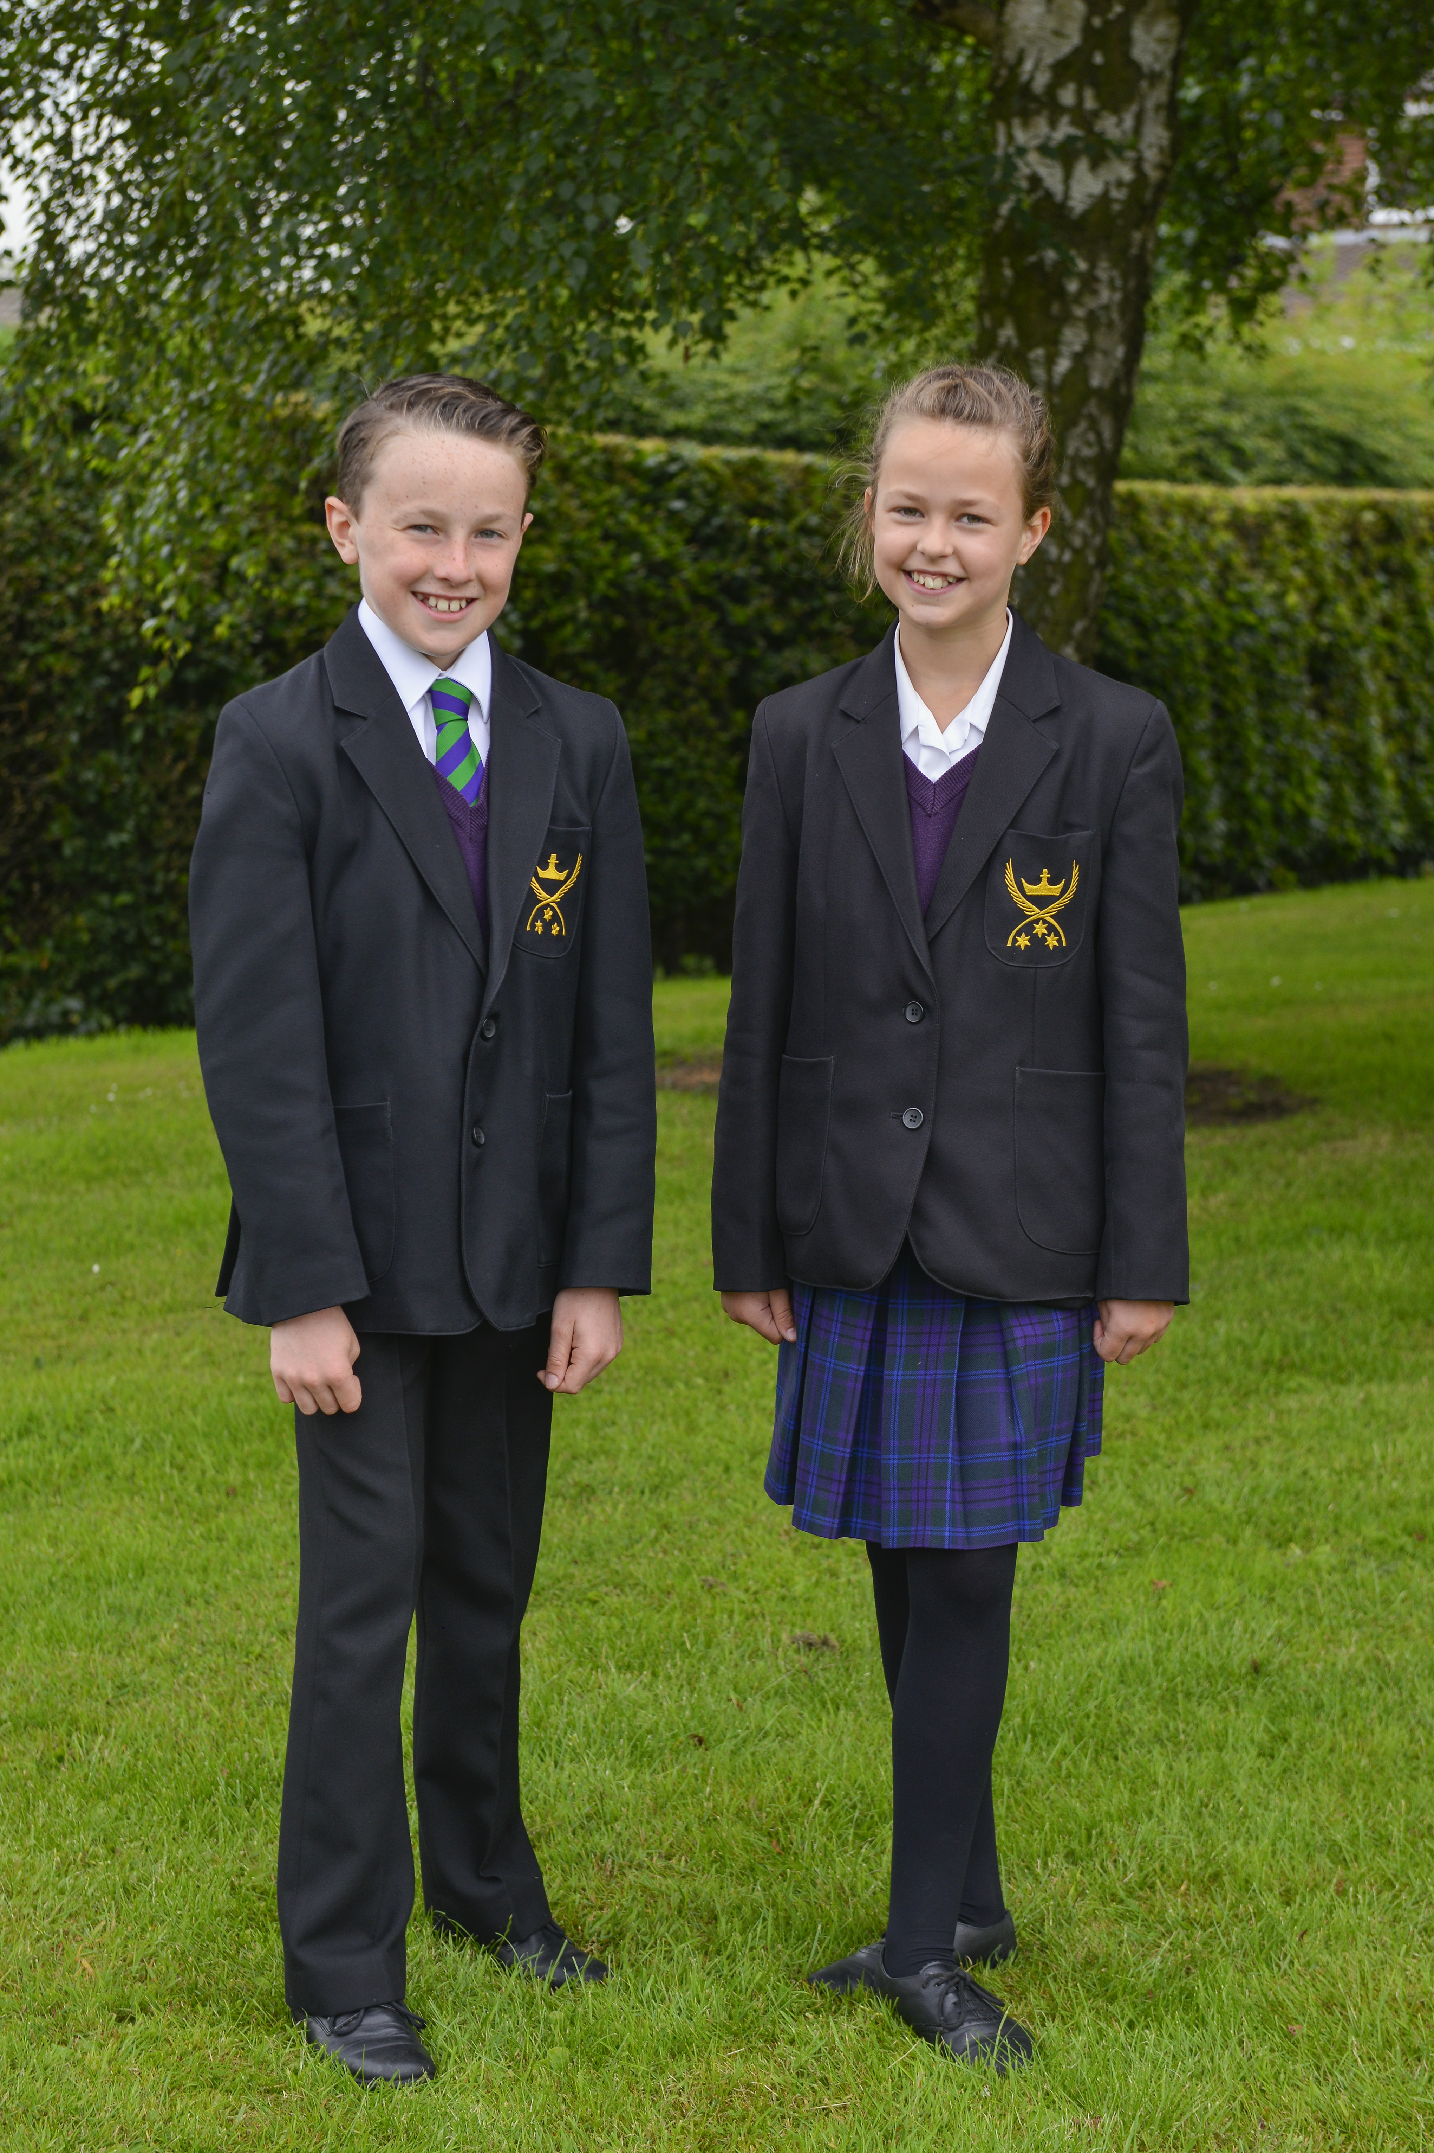

School uniform is compulsory for all pupils at All Hallows. It is our experience that the tone of the school depends to a large extent on school uniform. Pupils who resort to extremes of fashion or who repeatedly abuse the rules concerning school uniform will be sent home.

Boys’ Uniform
Black blazer with school badge.
Black straight leg trousers in plain material. Jeans, cotton material
trousers and other extremes of fashion are not acceptable (no skinny fit trousers).
White shirt in plain material (no button-down pockets).
Purple jumper – relevant size
School tie
Plain black shoes with no coloured markings or brand names. Trainers are to be worn only for PE.
Plain dark socks.
Outdoor coats to be worn rather than hooded tops.
Boys’ hair must be no shorter than a No.3 cut.

ALL ITEMS MUST BE CLEARLY MARKED

PE UNIFORM
Girls
Trainers - suitable sports trainers (no all black trainers)
Skort/Shorts - black with school badge
Polo Shirt - purple with school badge
Briefs - black
Sports Ankle Socks - plain white
Purple Socks
Gum Shield - for hockey lessons
Leggings - black with school badge (optional item)
Tracksuit Top - black with school badge – full zip (optional item)

Boys
Football Boots & Shin Guards
Trainers - suitable sports trainers (no all black trainers)
Football socks - pair purple
Shorts - black with school badge
Polo Shirt - purple with school badge
Sports Ankle Socks - plain white
Gum Shield - optional but advised for rugby lessons
Tracksuit Bottoms - black with school badge (optional item)
Tracksuit Top - black with school badge – ¼ zip (optional item)

PE kit should have a nametape in every item of clothing.
All PE footwear should be marked inside.

Technology Apron - Cream (available from suppliers)
Art Apron - White (available from suppliers)

GENERAL
Hair – must be left its natural colour. Hair adornments for girls should be plain purple or black. Hair extensions are not allowed.
Pupils must not have hair cut in an unacceptable extreme of fashion e.g. hair, which is shaved, wedged spiked with ‘gel’ or stiff with mousse or spray.
Boys’ hair should be neat, above the collar and no shorter than No.3.
Jewellery – girls with pierced ears may wear one pair of plain gold or silver studs in their lower earlobe.
Girls must be able to remove the earrings for PE.
Double earrings are not permitted.
Boys are not permitted to wear earrings.
No other jewellery is allowed.
Make-up, nail varnish and acrylic/gel nails are not allowed.
Bags – should be strong enough to protect books and should not be bigger than a briefcase.
Graffiti – bags, pencil cases, exercise books etc., must have no graffiti on them.
For safety reasons girls’ shoes should have a low heel, but no higher than 2”. Extremes of fashion are not acceptable.

PERSONAL PROPERTY
Each pupil is responsible for his/her own property and each item should be clearly marked or labelled with the pupil’s name. Although we keep a very close watch on property and provide pupils with lockers where possible, we cannot accept responsibility for losses. For this reason, no expensive items of personal property, including jewellery, should be brought to school. If on occasion sums of money or valuables have to be brought to school, then they must be left with Form Teachers or the School Office for safekeeping.

plan of the school
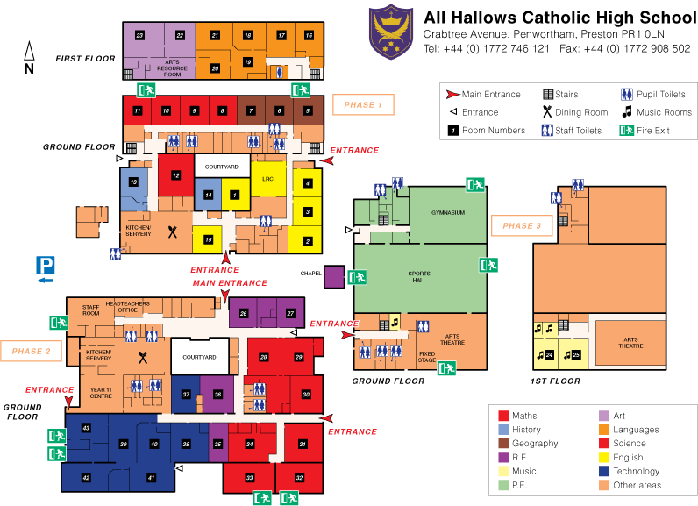

HOLIDAY LIST

Pupil Holiday List 2020/2021

 | First Day Open | First Day Closed
Autumn Term 2020 | Thursday 3rd September 2020 | Monday 26th October 2020
 | Monday 2nd November 2020 | Monday 21st December 2020
Spring Term 2021 | Monday 4th January 2021 | Monday 15th February 2021
 | Monday 22nd February 2021 | Friday 2nd April 2021
Summer Term 2021 | Monday 19th April 2021 | Monday 3rd May 2021
 | Tuesday 4th May 2021 | Monday 31st May 2021
 | Monday 7th June 2021 | Monday 19th July 2021

We ask parents NOT to take pupils out of school outside these times.

Time taken out of school can seriously affect a pupil’s progress.

FOLLOWING INSTRUCTIONS FROM LANCASHIRE COUNTY COUNCIL,

THE SCHOOL IS NOT ALLOWED TO AUTHORISE AN ABSENCE

FOR HOLIDAY PURPOSES.



